avataxAccount4j Interface Update Instructions

Run WSDL2Java to generate a new proxy into the newsrc directory

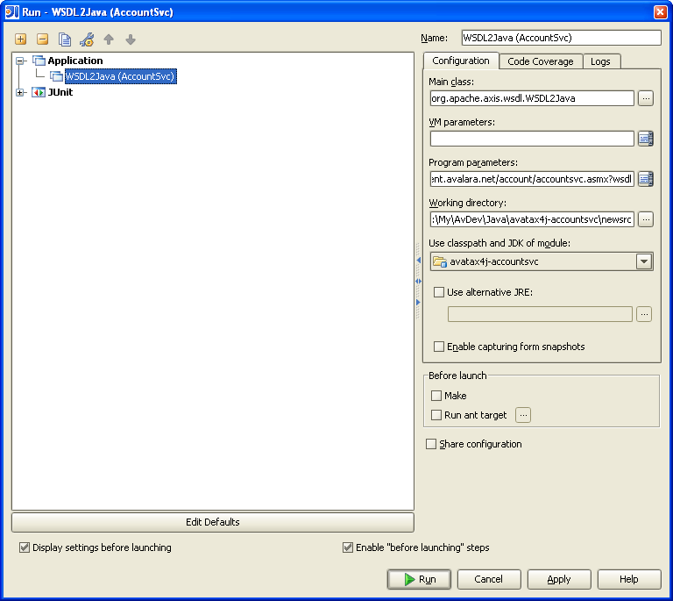

Create an account folder under newsrc\com\avalara\avatax\services and move all the generated source files to the new account folder. WSDL2Java generates it this way because the WSDL namespace is avalara.avatax.services.com.

Right click on the newsrc\com\avalara\avatax\services\account folder and choose Replace in Path and replace: com.avalara.avatax.services
with: package com.avalara.avatax.services.account

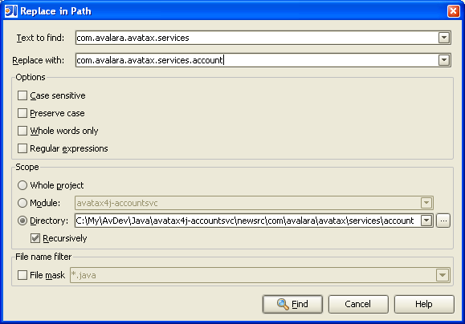

Also Search and Replace
Text to find: org.apache.axis.encoding.ser.BeanDeserializer
Replace with: com.avalara.avatax.services.base.ser.BeanDeserializer

Text to find: com.avalara.avatax.services.base.ser.BeanDeserializerFactory
Replace with: org.apache.axis.encoding.ser.BeanDeserializerFactory

Custom Merge the following files:
- AccountSvcLocator.java – Preserve // BEGIN CUSTOM to // END CUSTOM code
- AccountSvcSoap.java – Preserve BaseSvcSoap base class
- AccountSvcSoap12Stub.java – Preserve base class BaseSvcSoapStub
- AccountSvcSoapStub.java – Preserve base class BaseSvcSoapStub

Copy over the other files as is

To build the distribution zip file
- Update the version in build.properties
- Run: ant fulldist

